OBSERVATION 1:

There is no sign in button as per wireframe:

Local host:

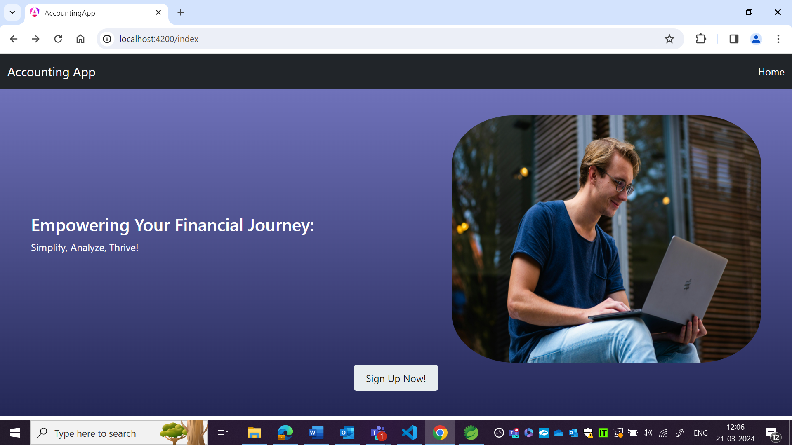

Wireframe:

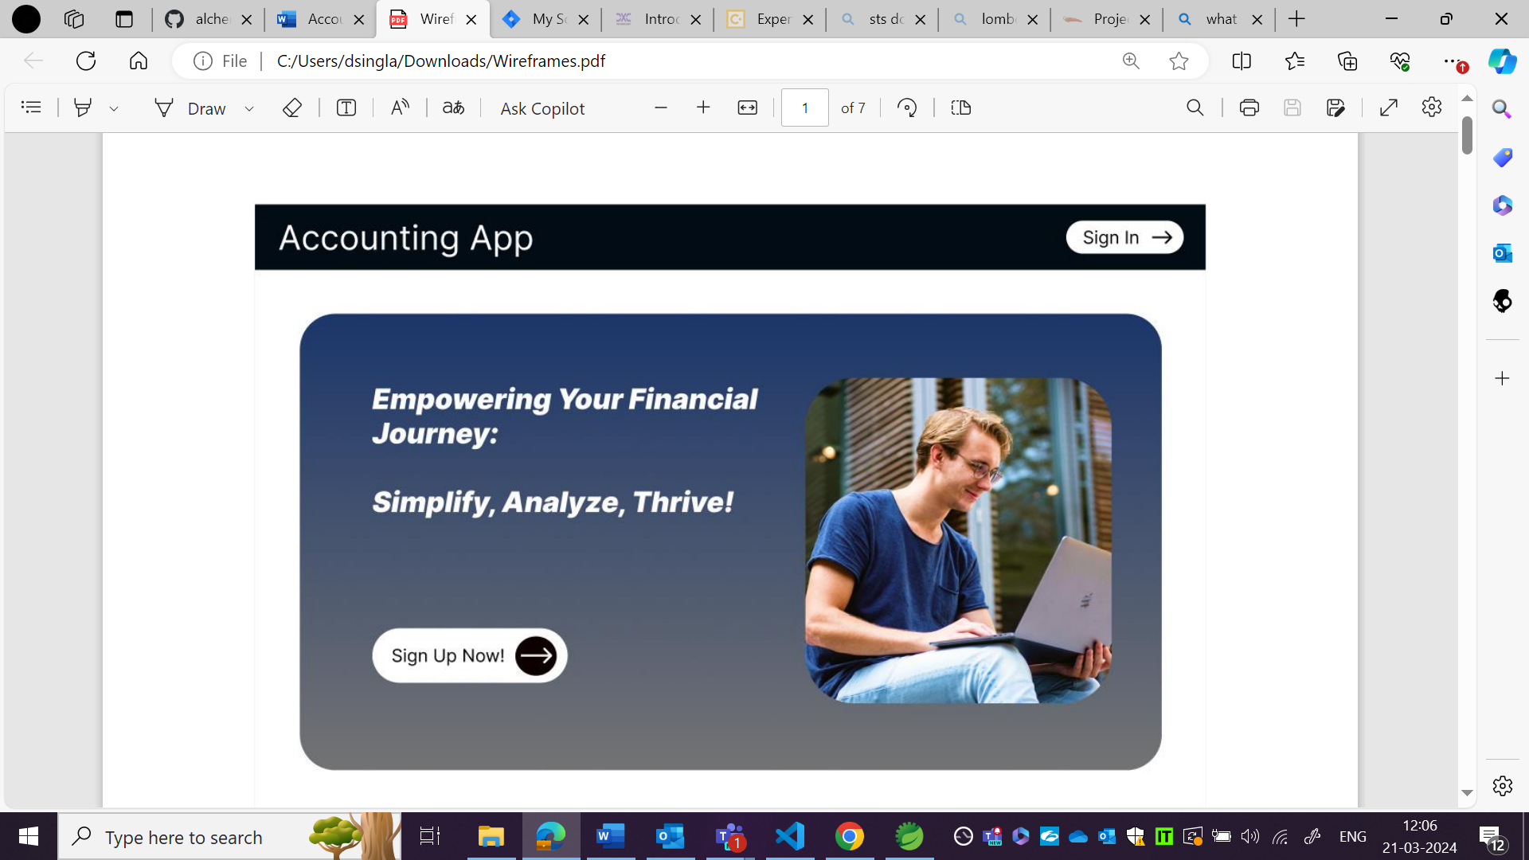

OBSERVATION 2:

Written text is in different format and sign up now button placement is also different as per wireframe.

Local host:



Wireframe:



OBSERVATION3:

When we are zooming out then screen is not in proper format. **Reproducing for all pages.**

Localhost:

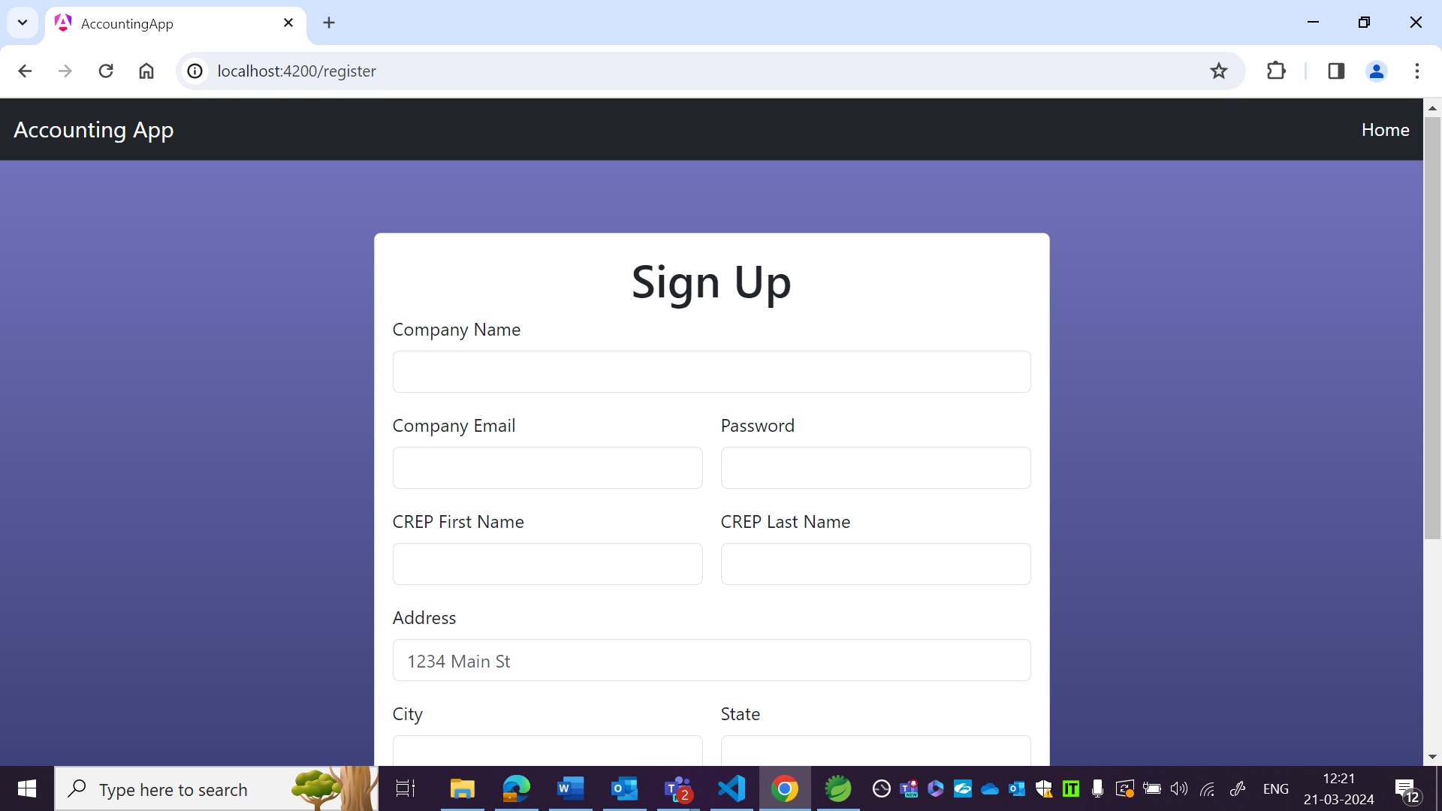

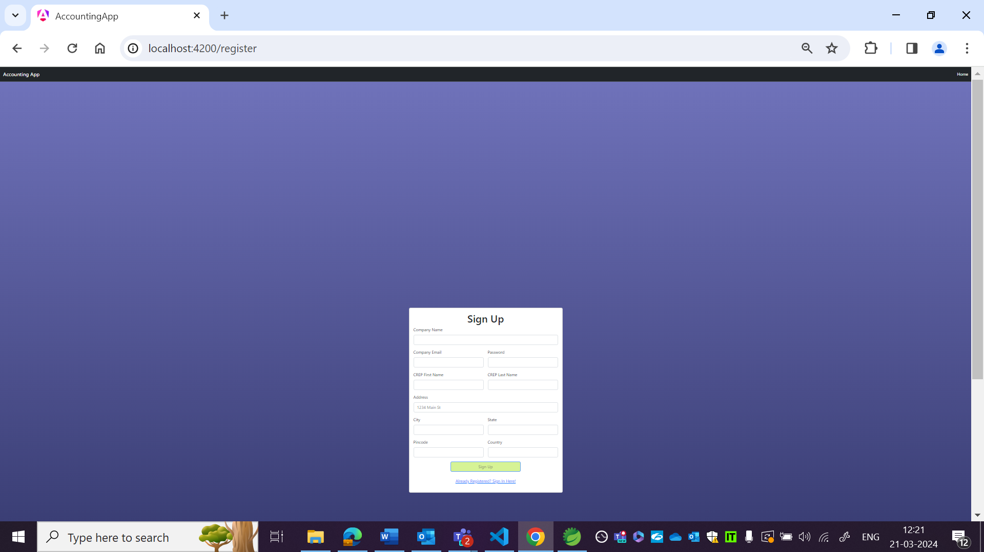

OBSERVATION4:

It is register at in wireframe but sign up in local host.

It is First name and last name in wireframe but CREP first name and CREP last name in localhost.

Wireframe:

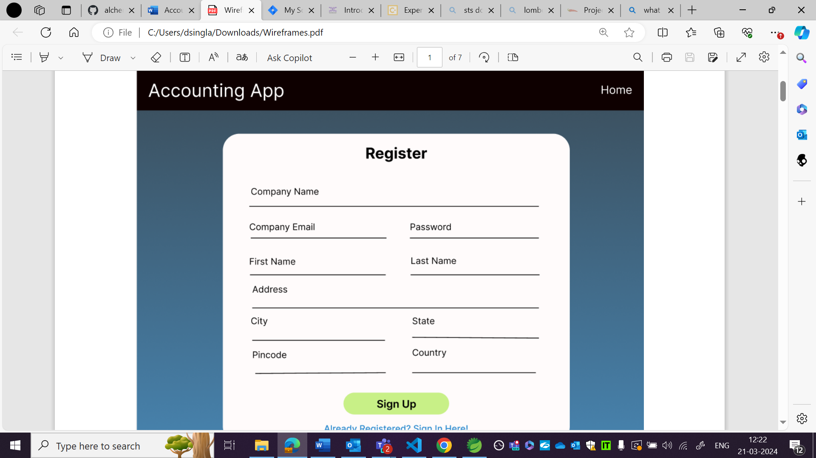

Local host:

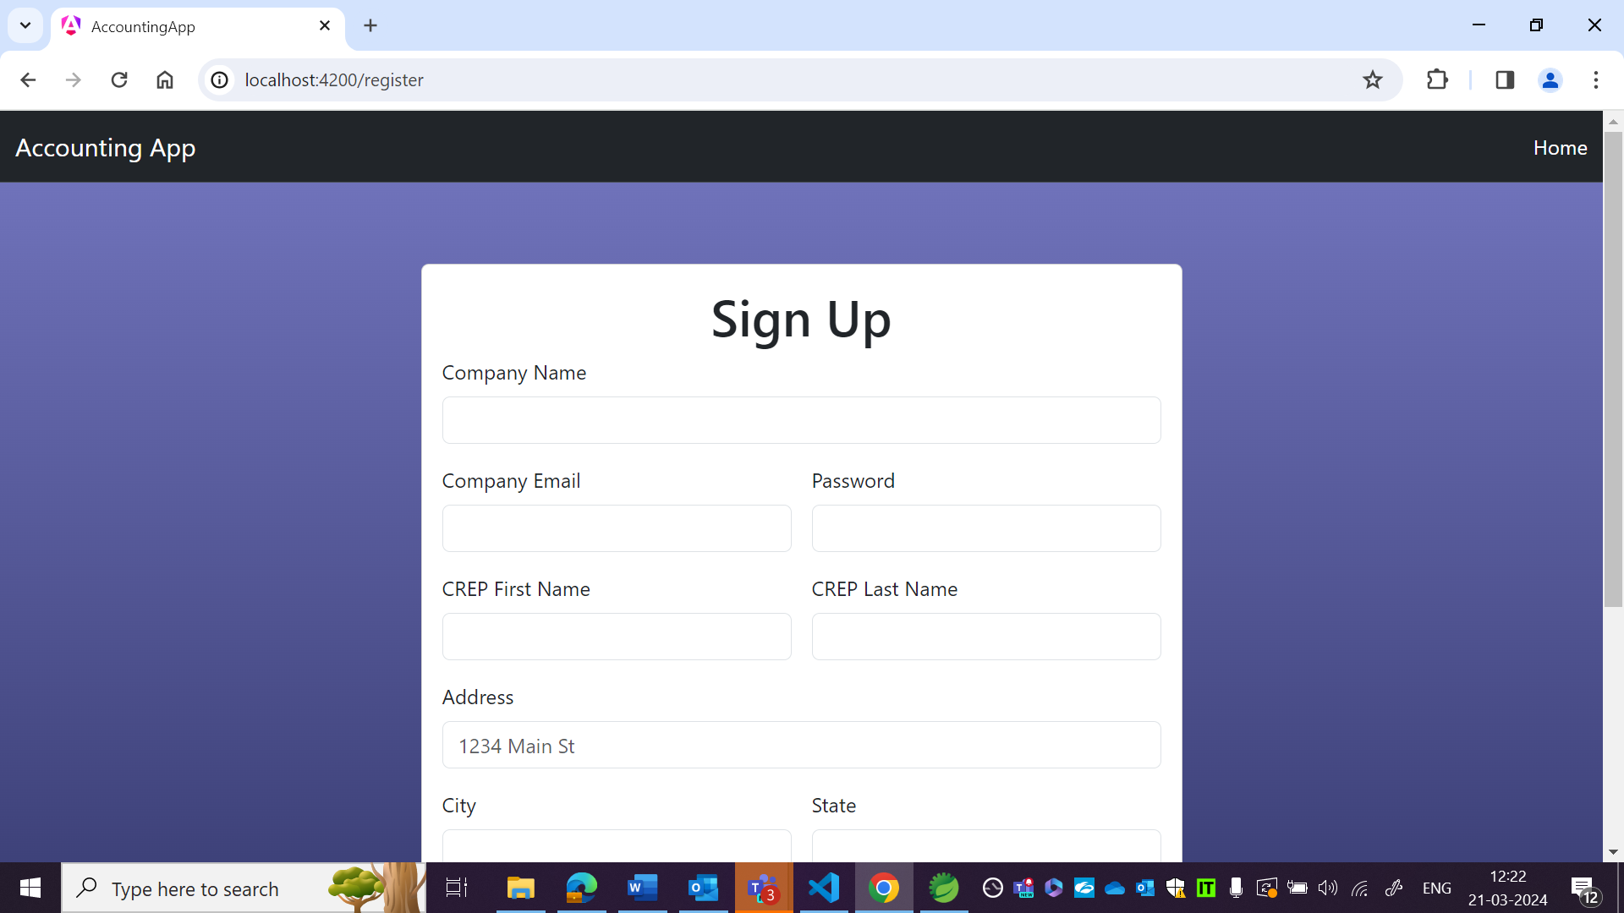

OBSERVATION 5:

Not throwing error even when email and password are not as per requirements in US.

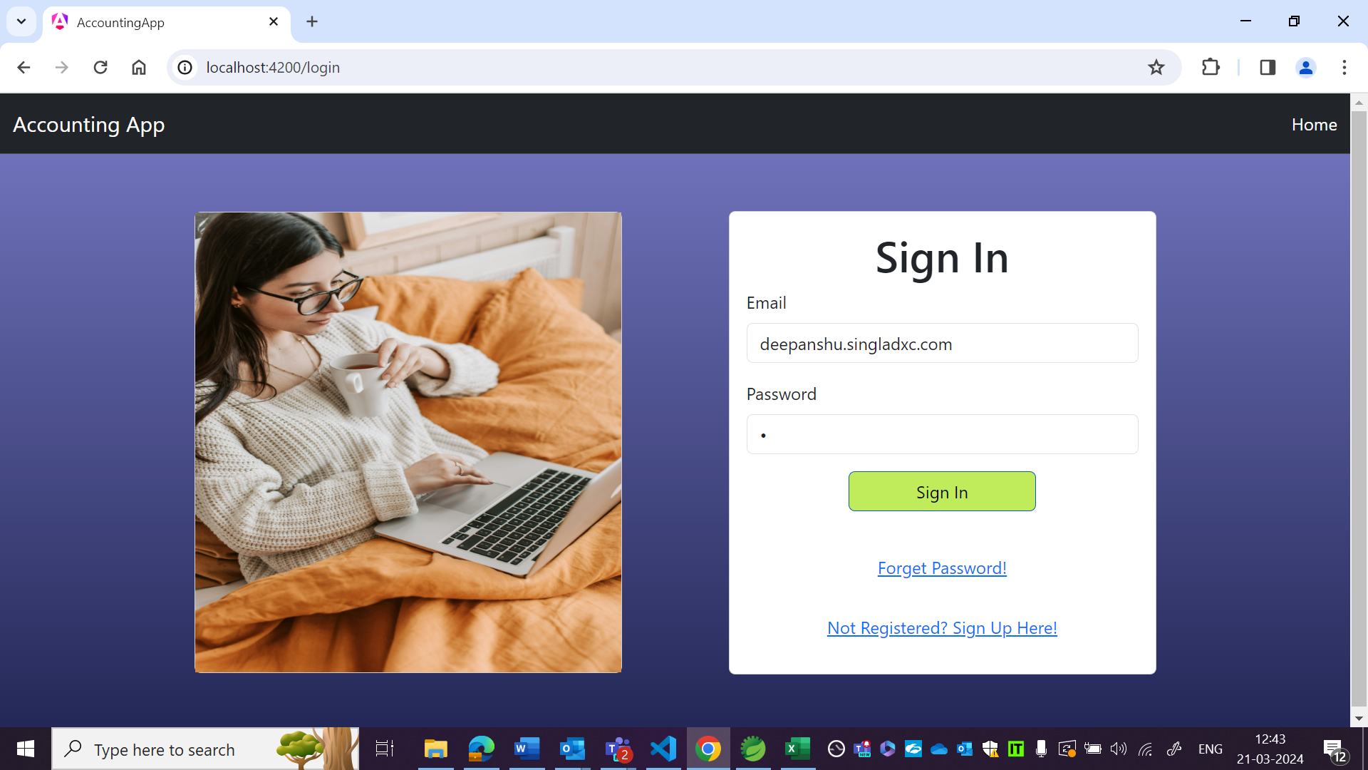

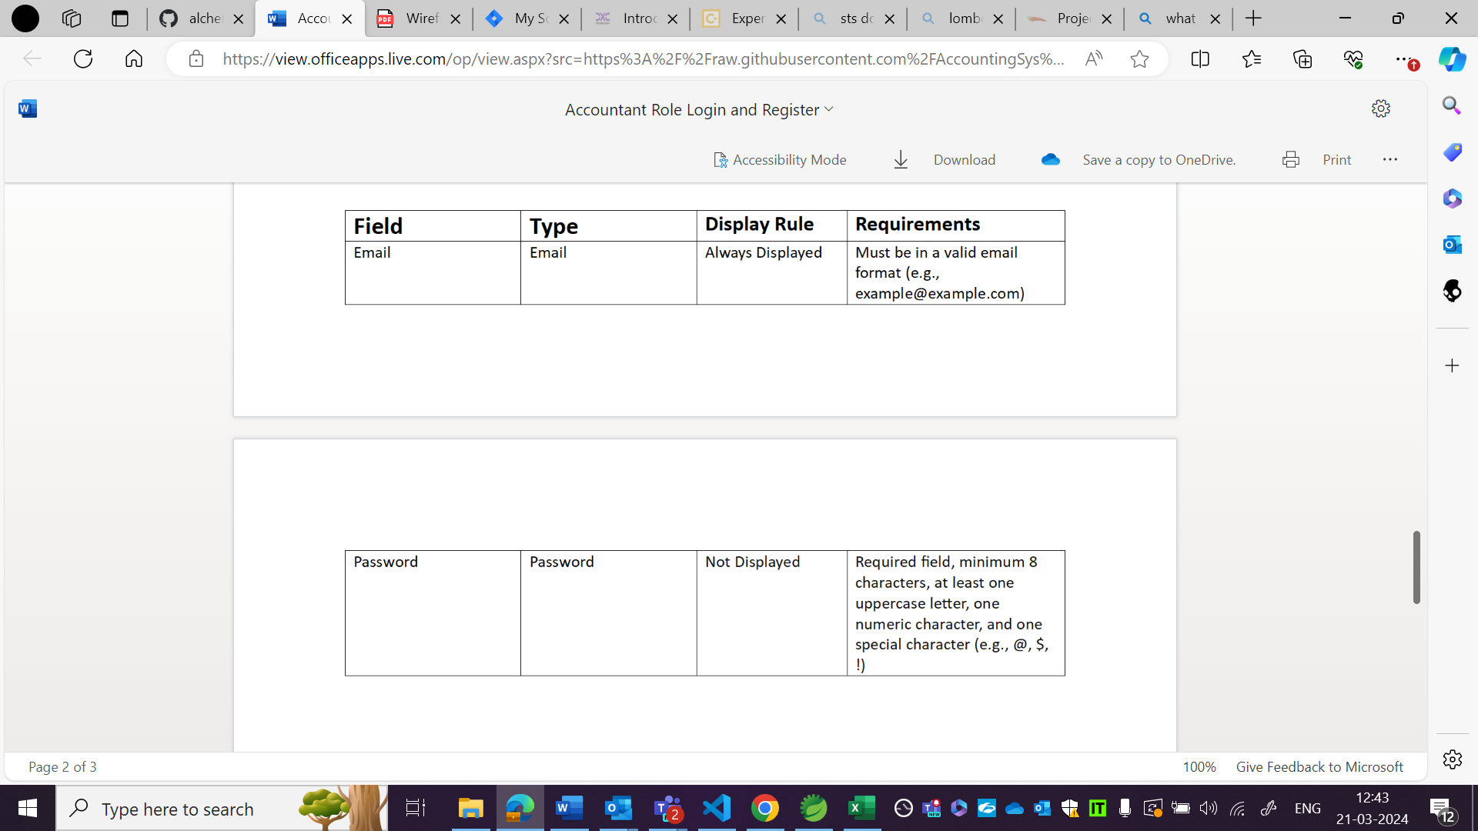

OBSERVATION6:

Forget password functionality is not working. There is ‘!’ after forget password is localhost but not in wireframe.

Local host

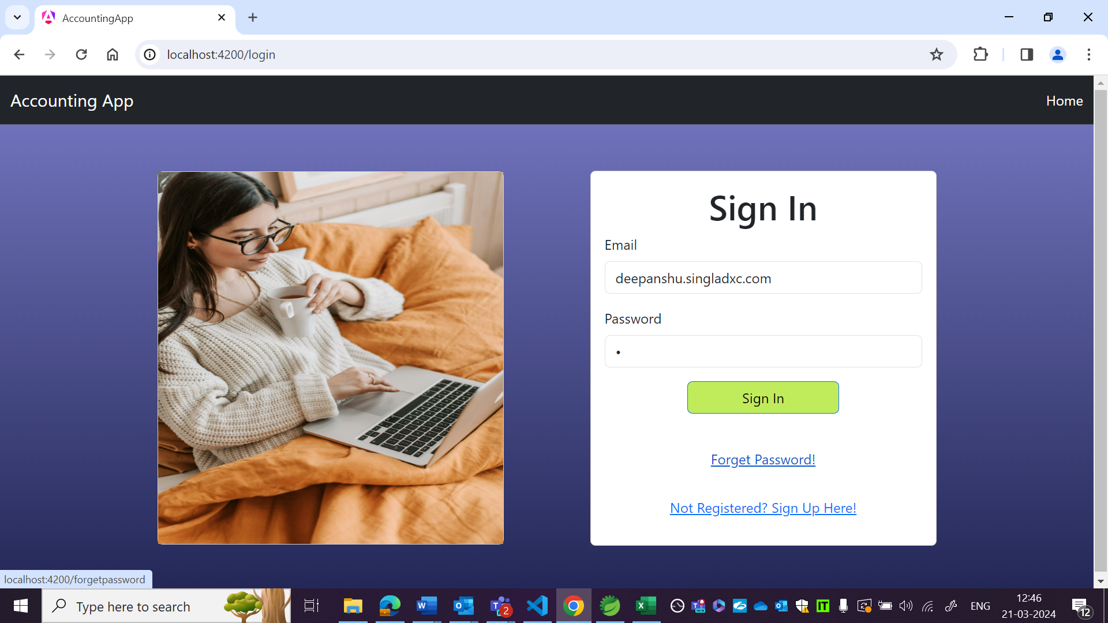

Wireframe:

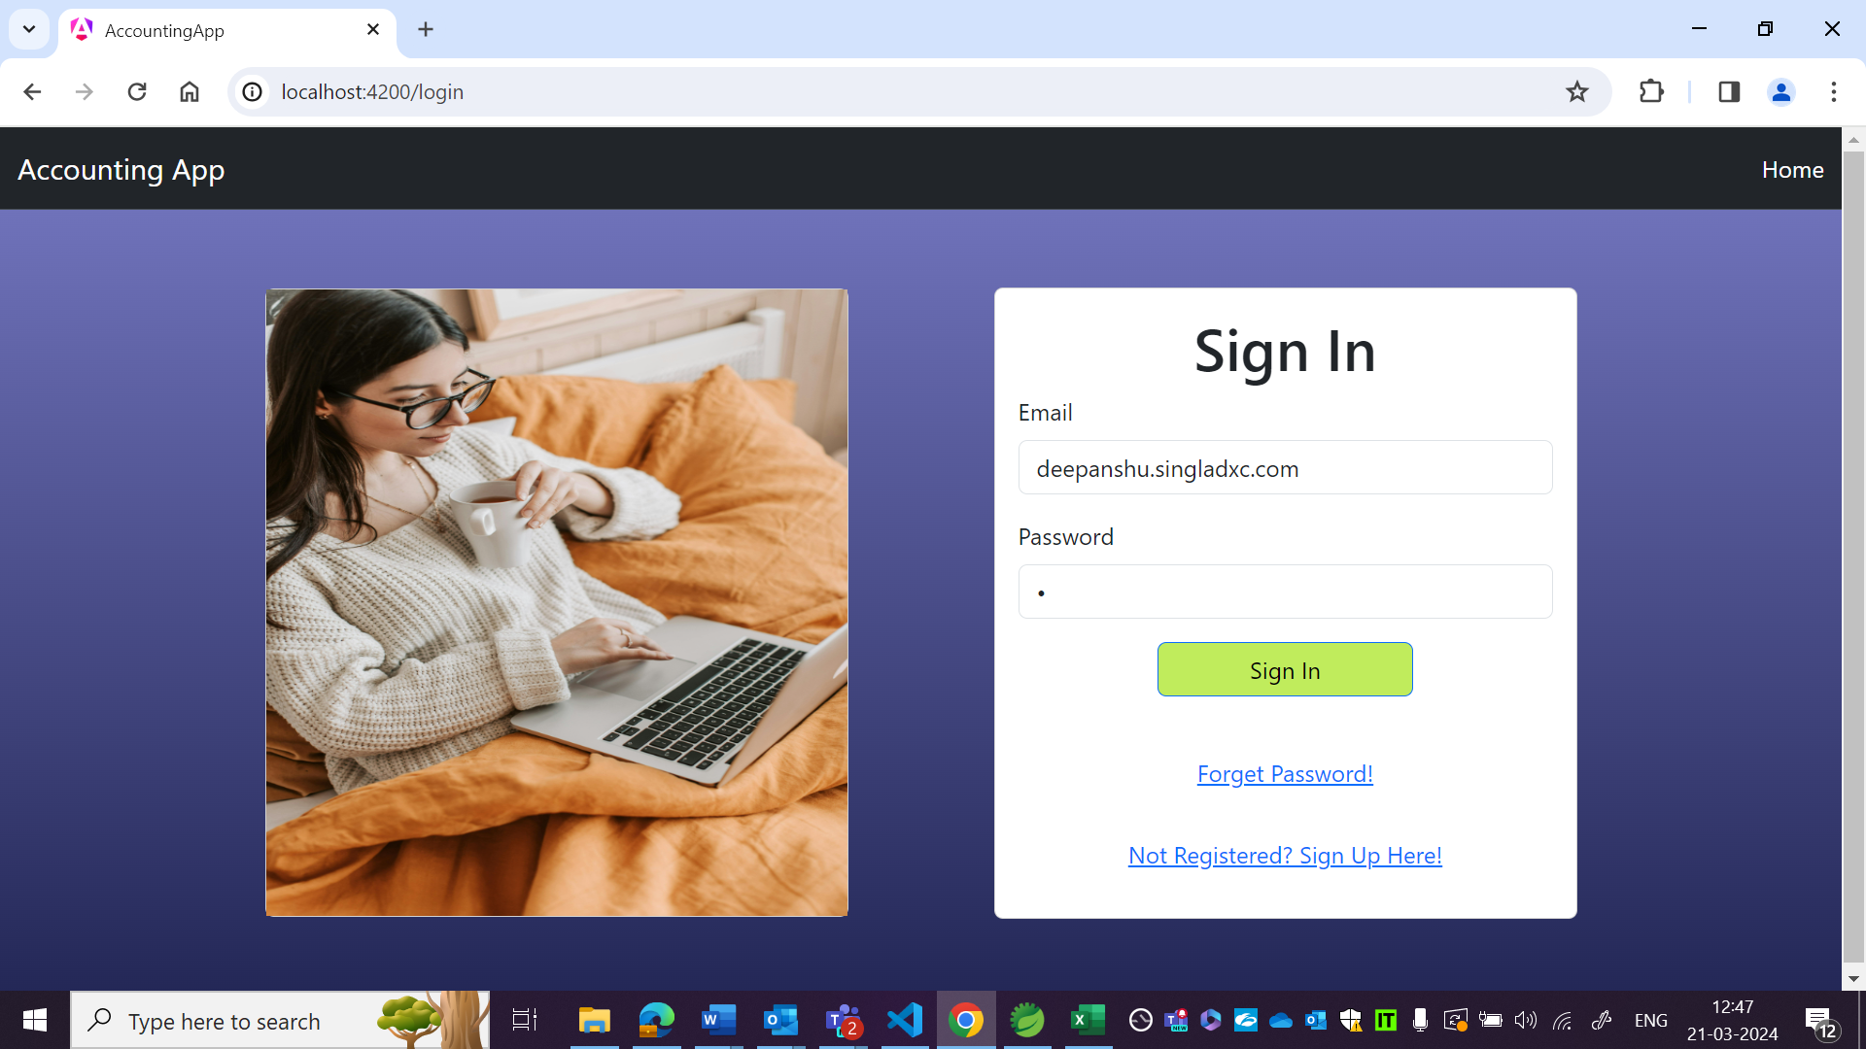

OBSERVATION7:

No error throwing when added company name, company email, password, first name, last name not as per requirements in US.

Local host:

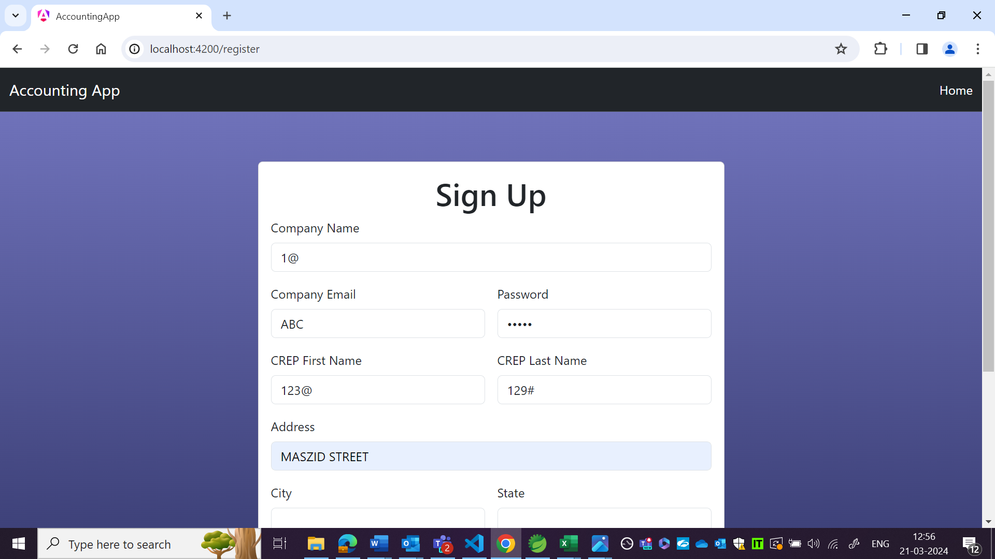

US:

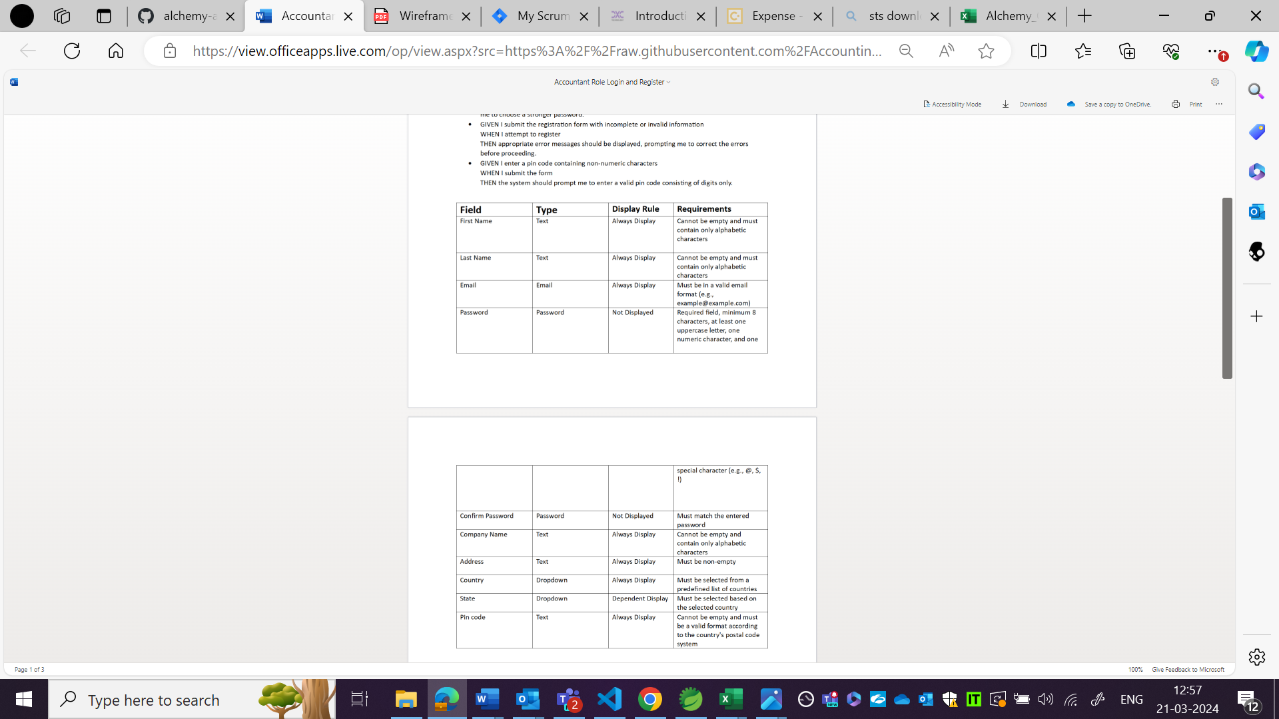

OBSERVATION 8

Country and state should be in dropdown format as per wireframe but theres no dropdown available in local host.

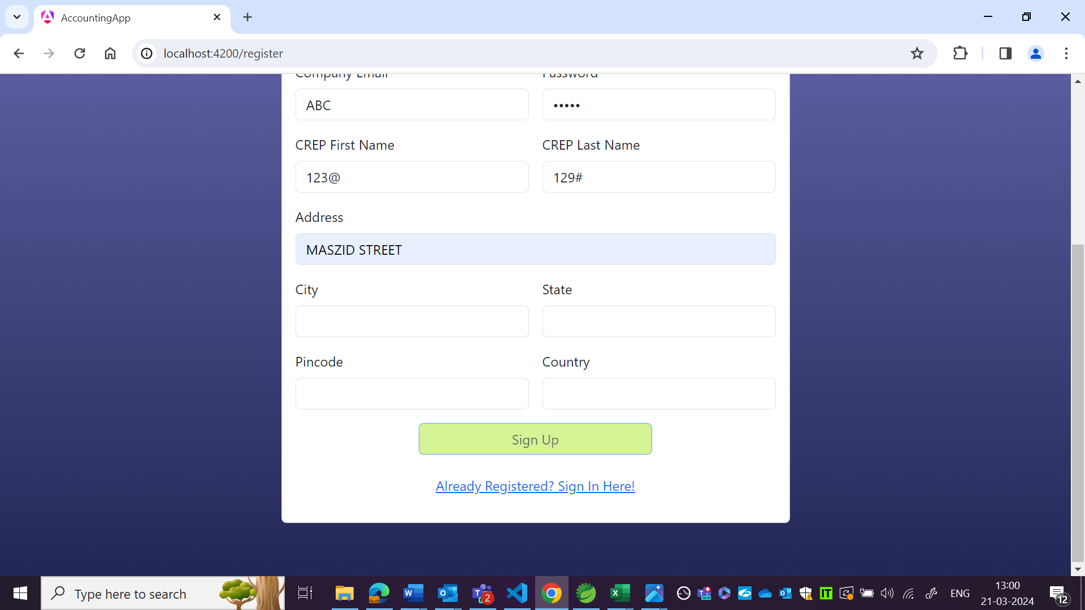

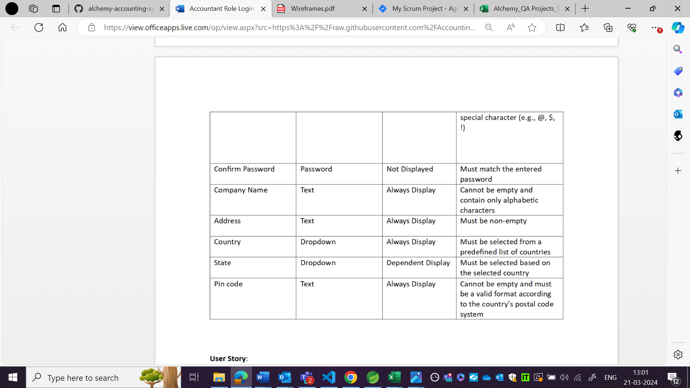

OBSERVATION9:

Local host:

Pincode should be in format as per country but it is not.

Local host:

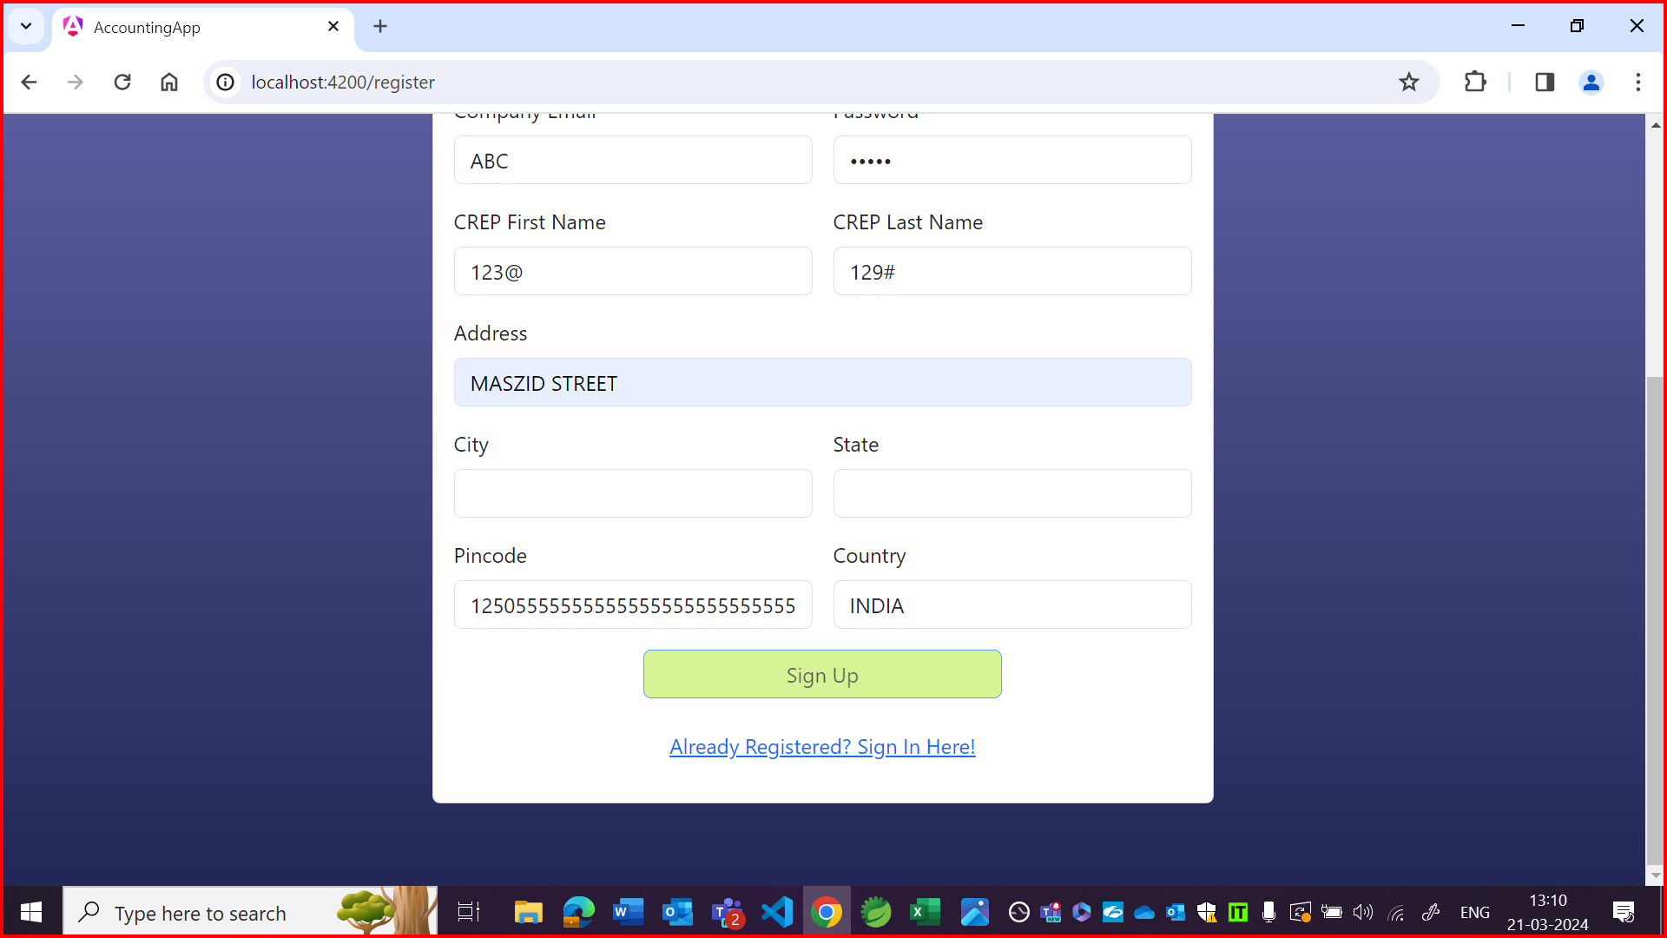

US:

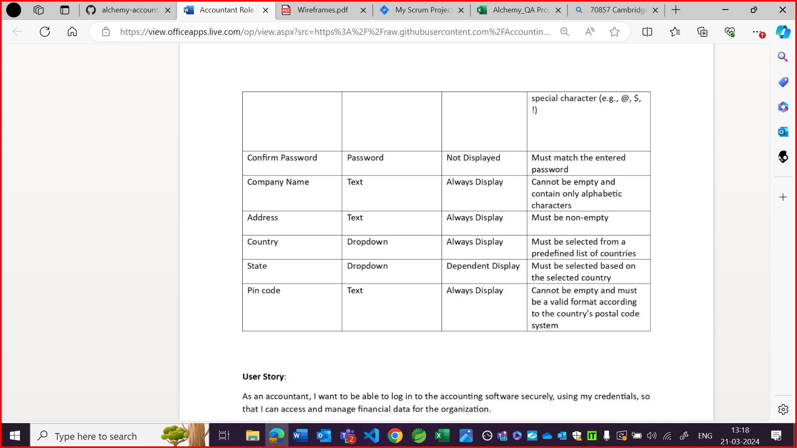

OBSERVATION10:

Confirm password field is not there in wireframe but it should be there as per requirements in US.

Although matching as per wireframe.

Local host:

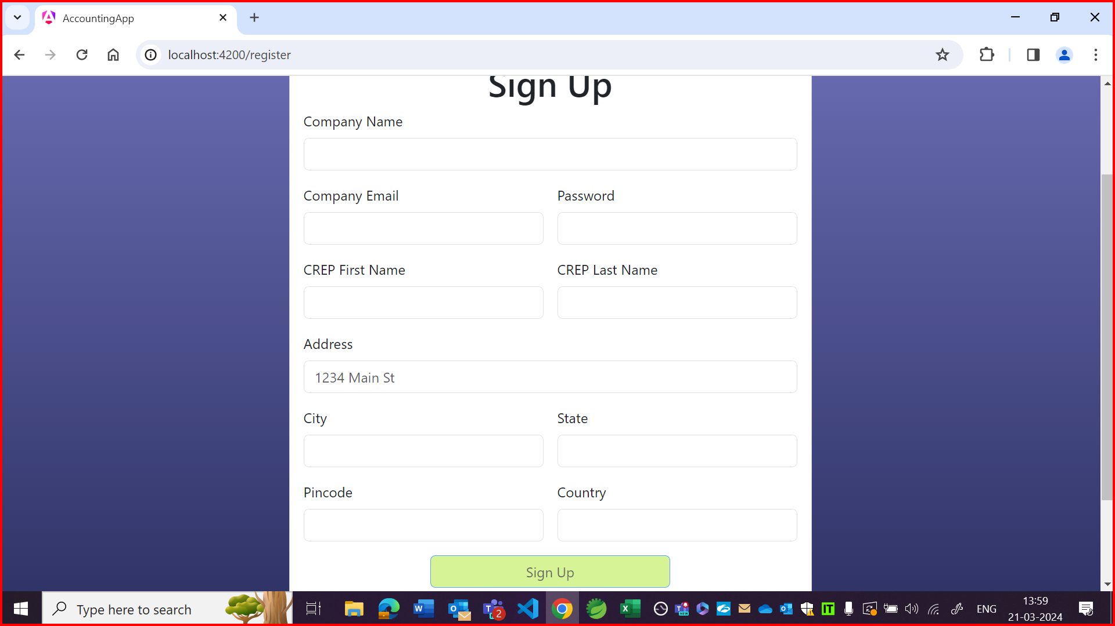

US:

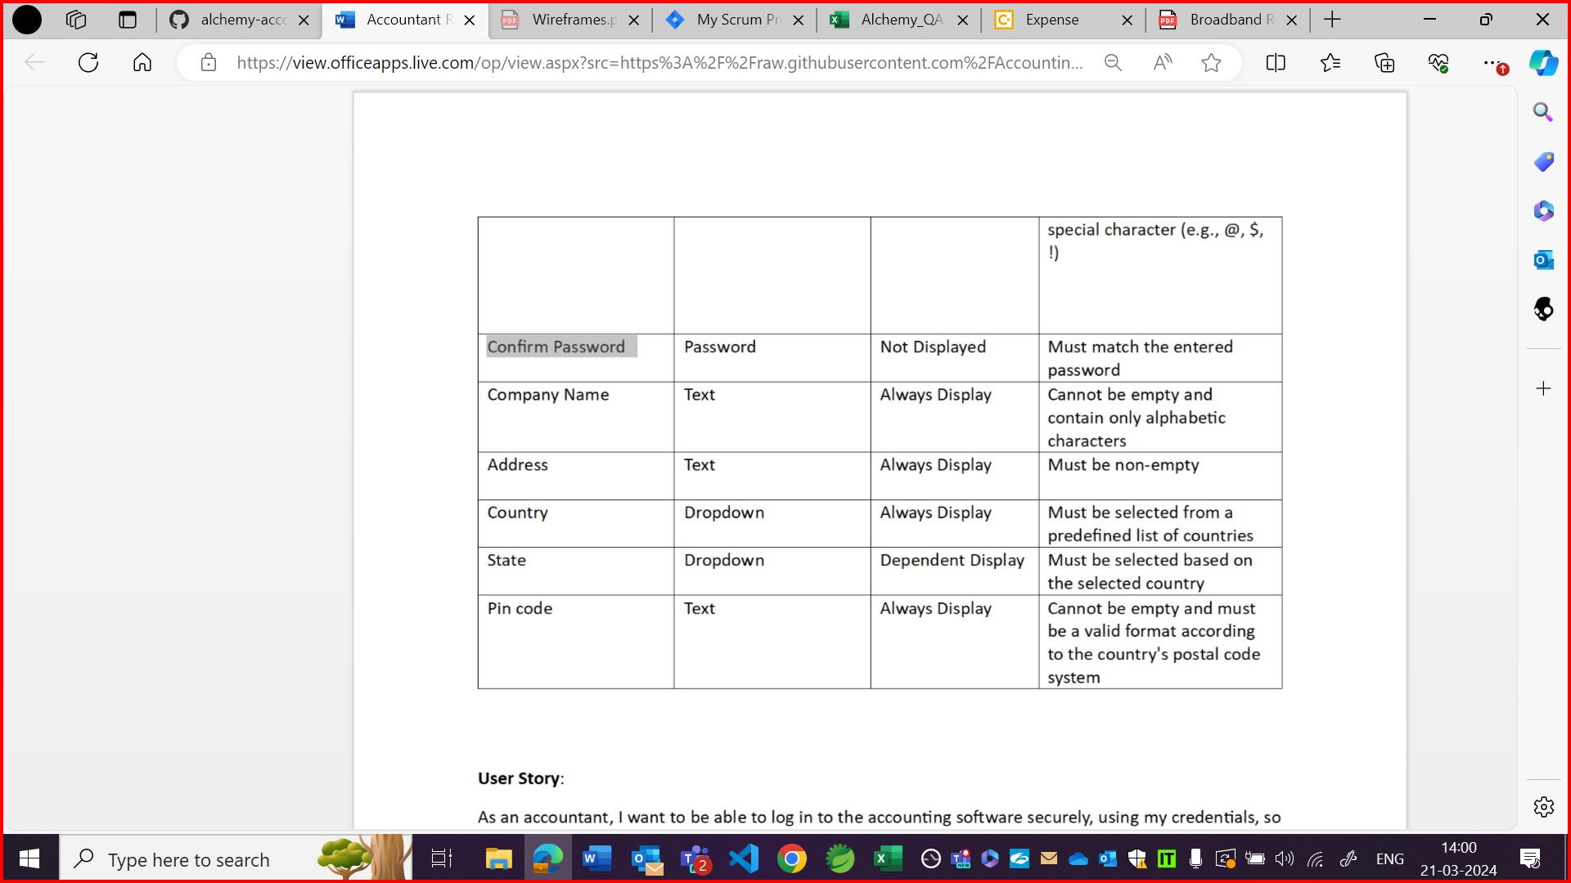

OBSERVATION11:

Home button is not in same placement as per wireframe. And highlighted boxes are not in same format as per wireframe.

Wireframe:

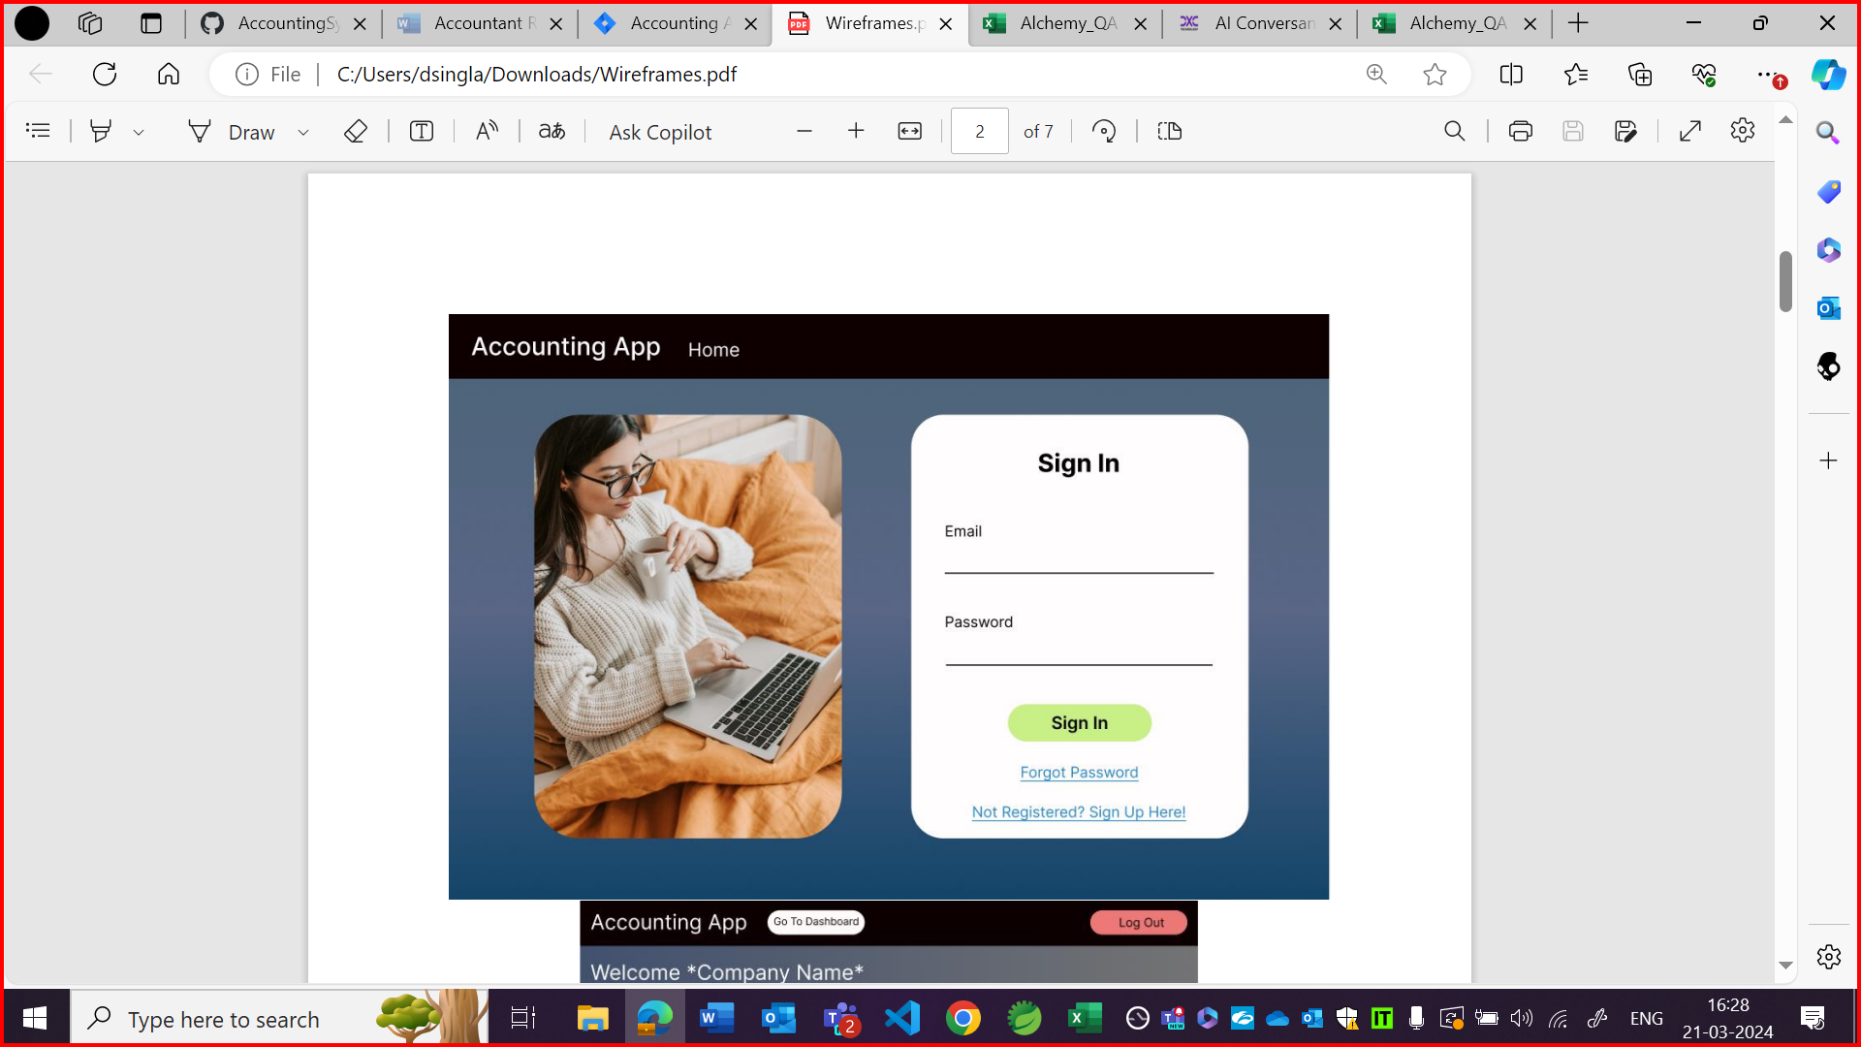

Localhost

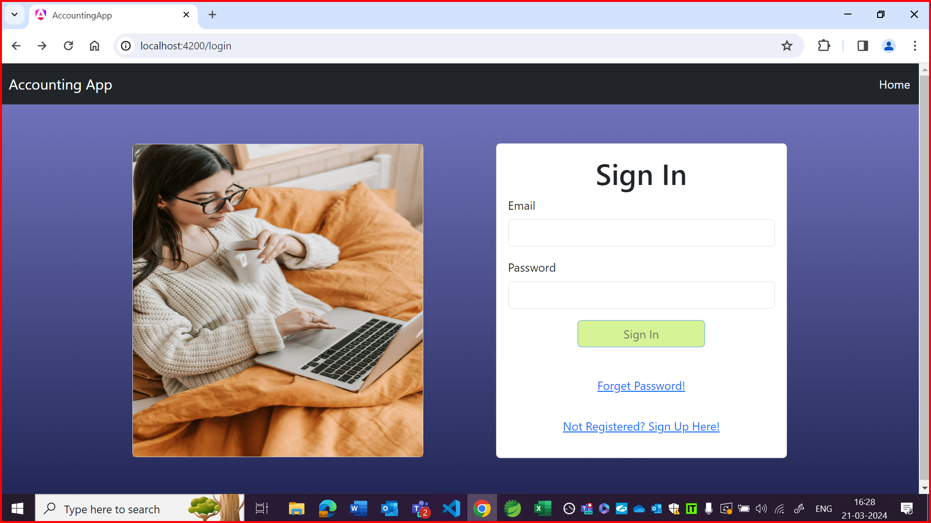

OBSERVATION12:

When got error in all fields, then box is expanding and overlapping the top bar.

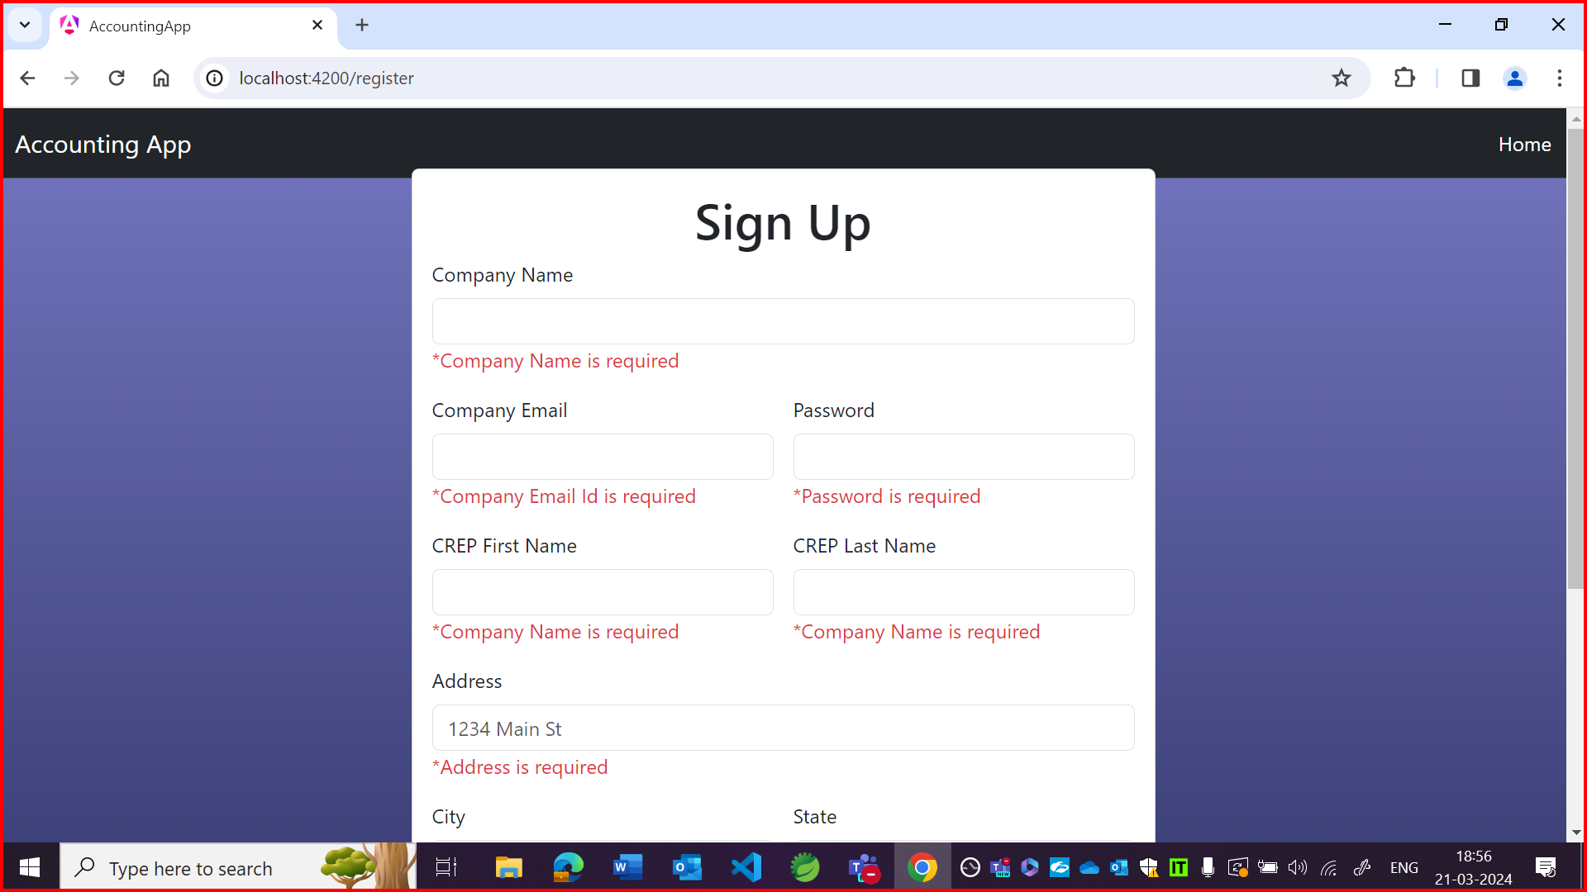

OBSERVATION13:

